ER-relational model  
Composite attribute should be included in the table with their own attributes  
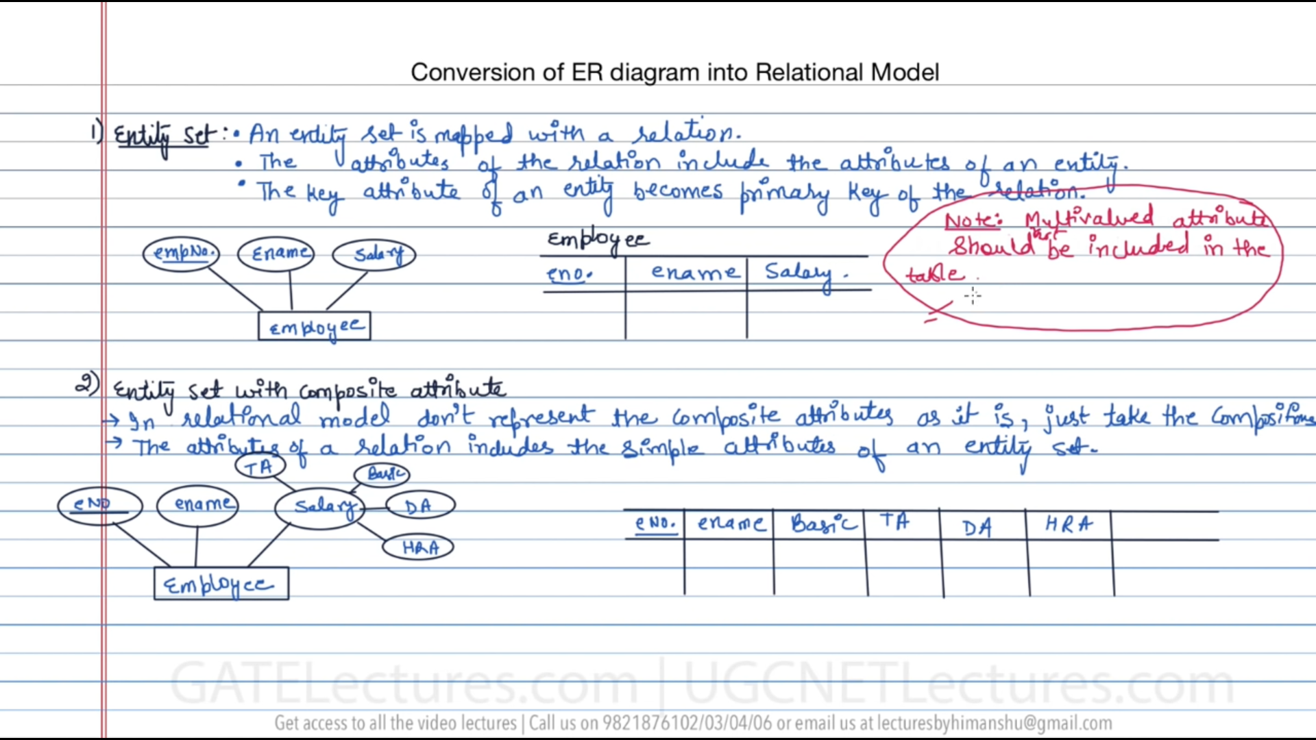

Multi-valued attributes contains more than 1 value for a specific record, So mentioning it in the relational model will consume a lot of space and repeated records might also occur.   
So these multi-valued attributes are put into a separate table.

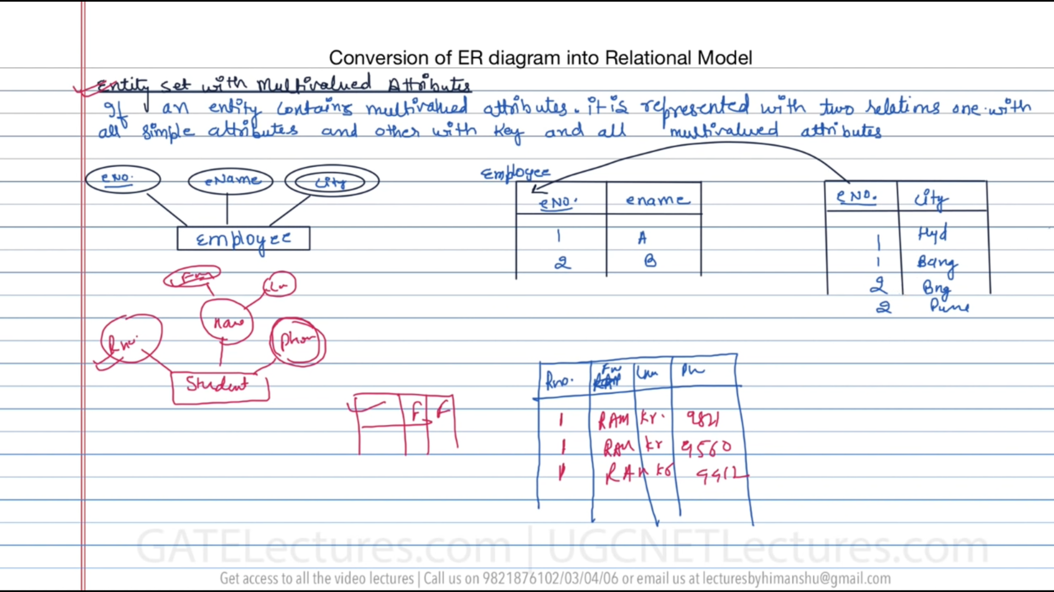

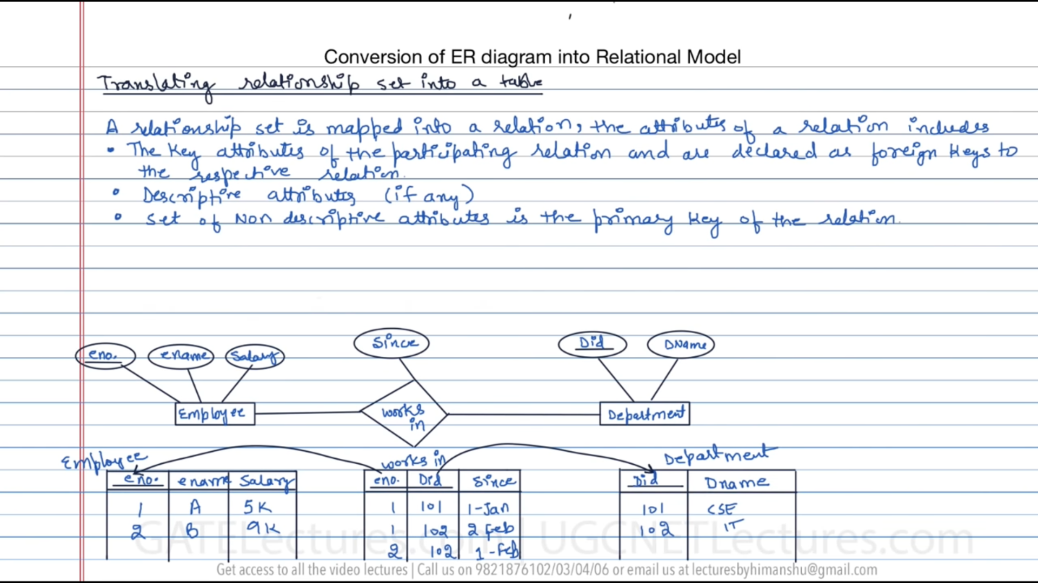

Relations are table   
Relationship is (works in) which connects both employee and department table.

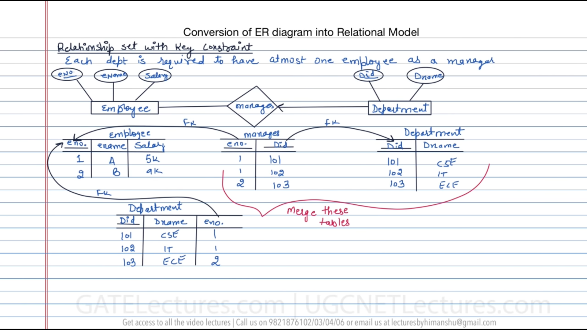  
department is in Many side, so the emp_no which the primary key in the employee table becomes the foreign key in the department table.  
Employee(**e_no**, ename, salary)  
Department(**Did**, Dname) Department(**Did**, Dname, e_no)  
Manages(**e_no,Did**)



1 to Many with total participation

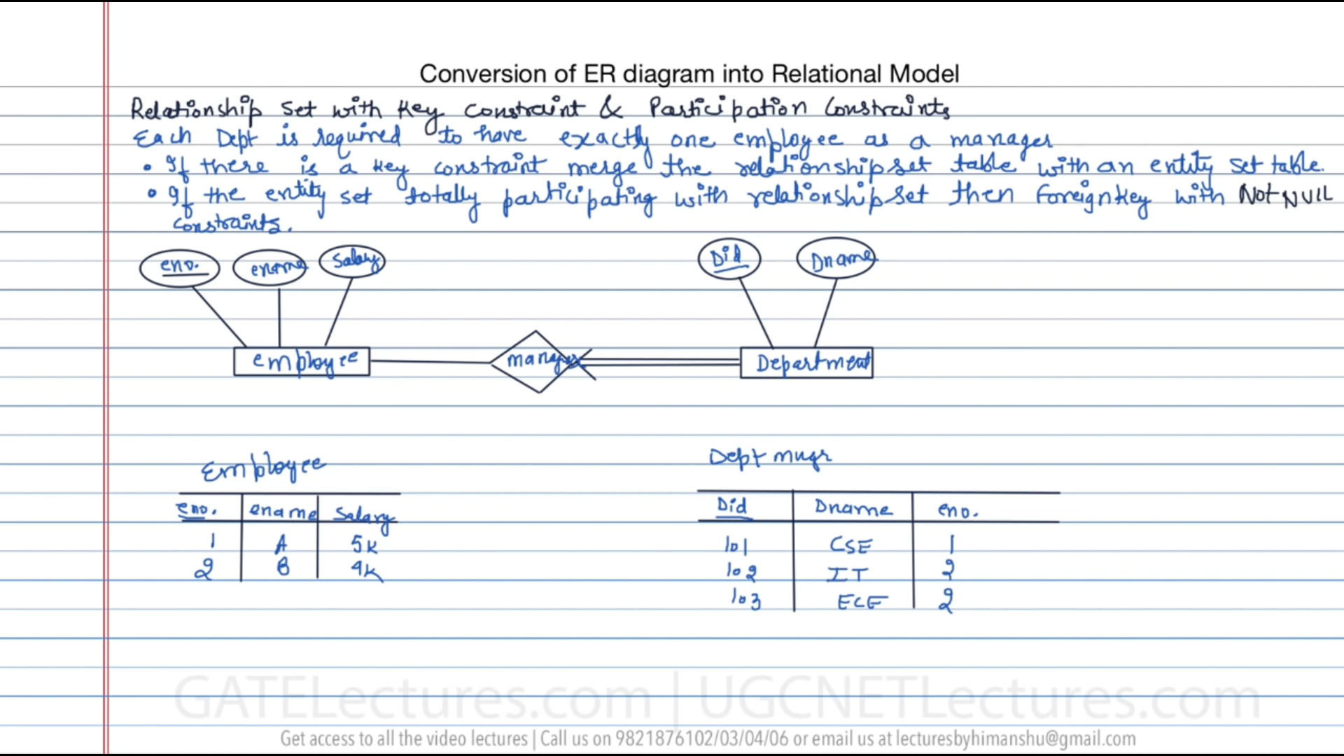



Many to many (with total participation) (Minimum cardinality=1)

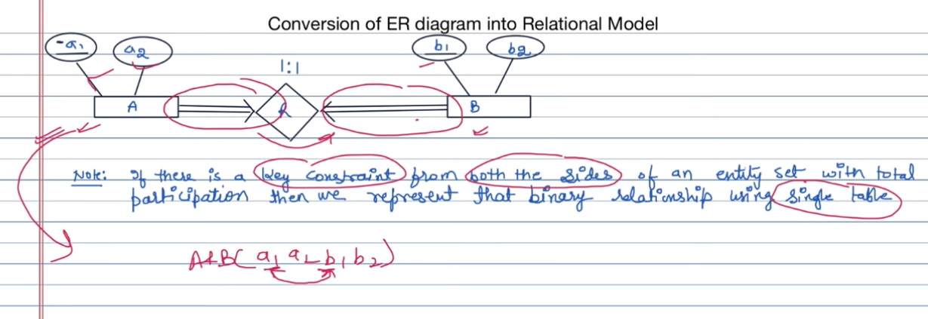

Combine both the tables A,B, A and B(**a1**,a2,**b1**,b2)  
Department is having total participation, (i.e minimum cardinality = 1)  
Question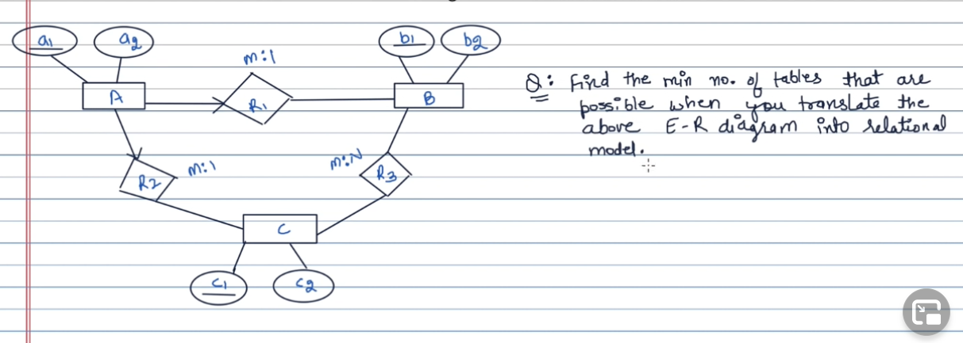  
B(**b1**,b2) | R3(b1,c1) | C(**c1**,c2) | AR1R2(**a1**,a2,b1,c1) Since A is 1 to 1 for both R1 and R2

For weak entity set [Create a separate table for the weak entity with the key attribute from the strong entity ]  
***(partial key of weak entity + primary key of strong entity 🡪 primary key of weak entity set table)***

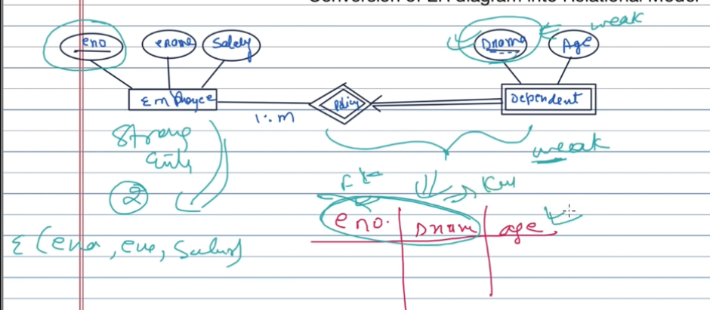

Question

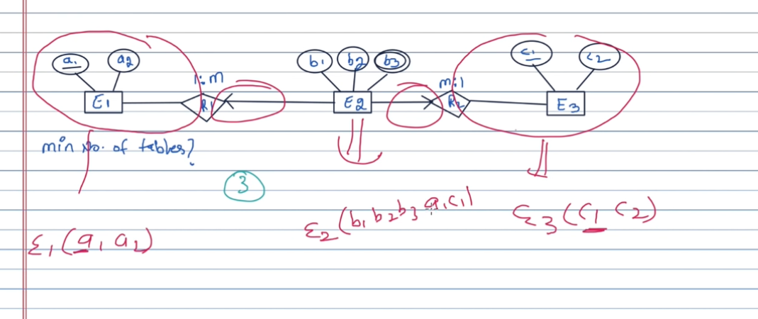

E2(b1,b2,**b3**,**a1,c1**)

Many to many (2 side no arrow)  
One to one(2 side arrow)

A 🡪 R – B (many to one)

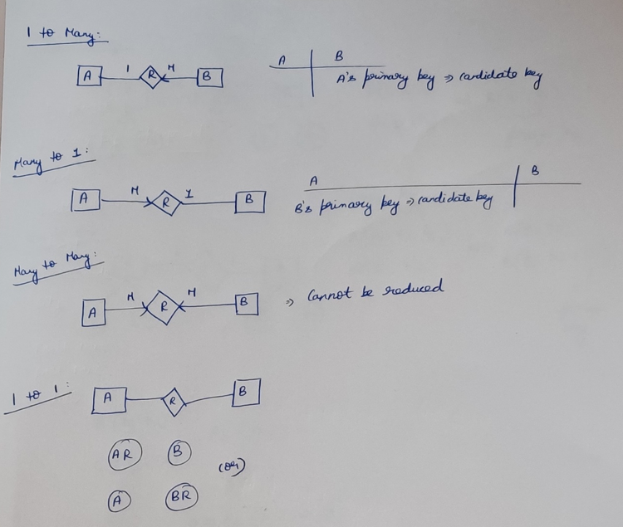

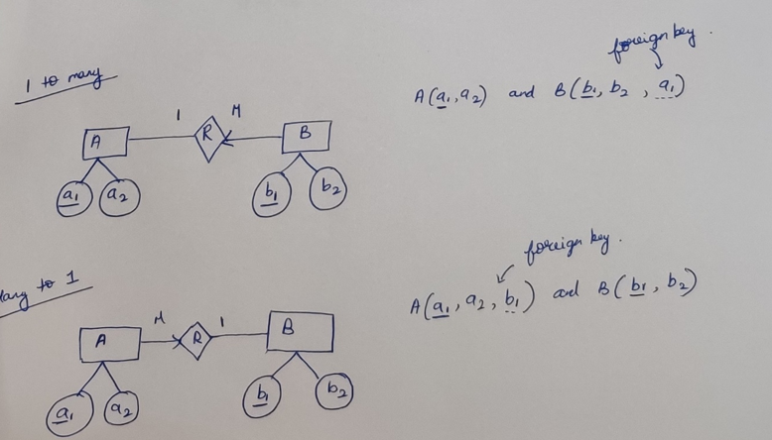

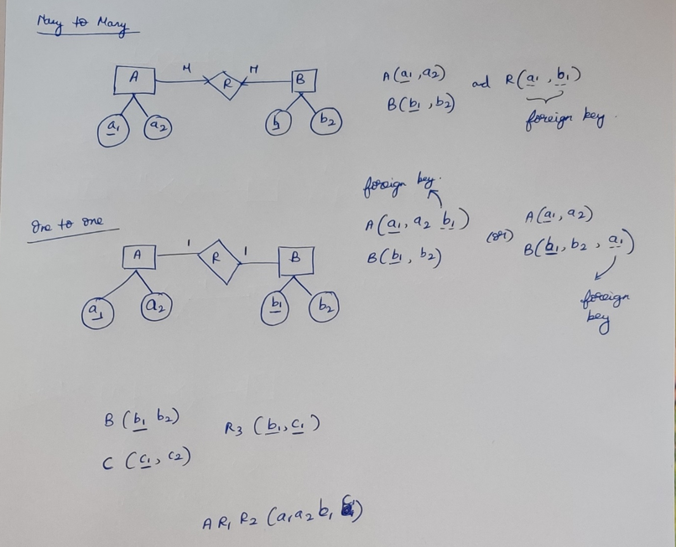

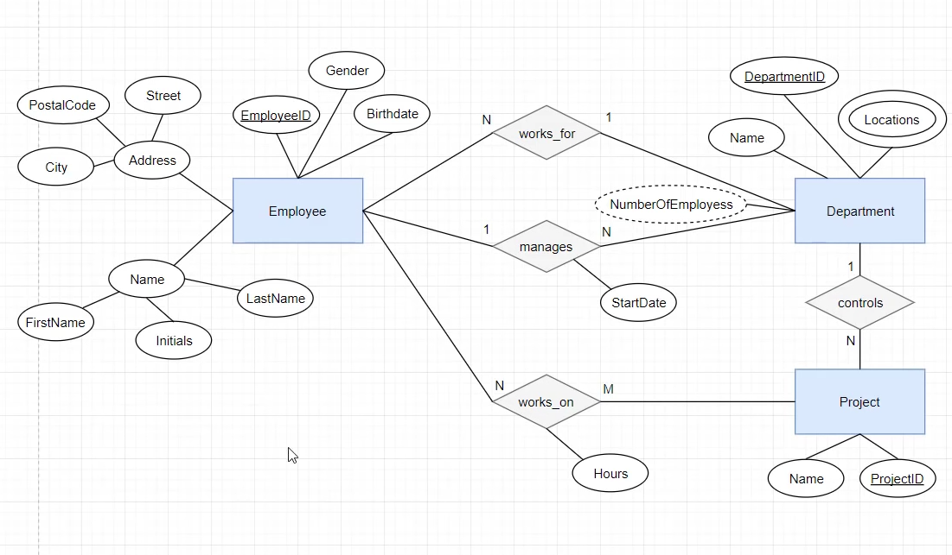

Question

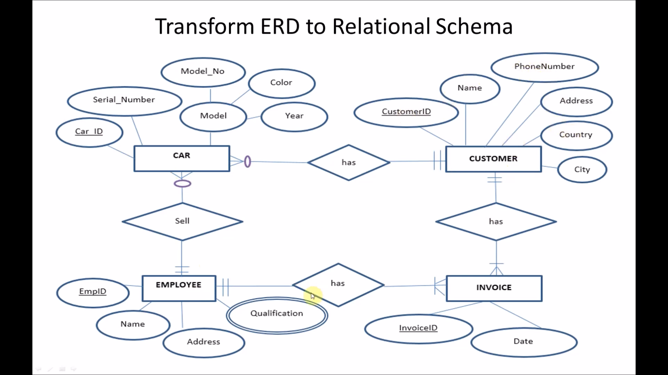

CAR(**Car_ID**, Serial_Number, Model_No, Color, Year, CustomerID, EmpID) (since car is on many side)  
/* Here Model is a multi-valued attribute, containing Model_No, Color, Year */  
CUSTOMER(**CustomerID**, Name, PhoneNumber, Address, Country, City)  
INVOICE(**InvoiceID,**Date,EmpID, CustomerID) (since invoice is on many side)  
EMPLOYEE(**EmpID**, Name, Address)  
EMPLOYEE_QUALIFICATION(**Qualification**, EmpID)

